

<Andrew Bolton>

# **CS 230 Project Software Design Template**

Version 1.0

## Table of Contents

**CS 230 Project Software Design Template**1

**Table of Contents**2

**Document Revision History**2

**Executive Summary**3

**Design Constraints**3

**System Architecture View**3

**Domain Model**3

**Evaluation**3

**Recommendations**5

## Document Revision History

| Version | Date | Author | Comments |
| --- | --- | --- | --- |
| 1.0 | <05/23/21> | <andrew> | <Brief description of changes in this revision> |

**Instructions**

Fill in all bracketed information on page one (the cover page), in the Document Revision History table, and below each header. Under each header, remove the bracketed prompt and write your own paragraph response covering the indicated information.

## Executive Summary

The Gaming Room wants to develop a web-based game similar to the 1980s tv game called Win it or draw . That can run on multiple platforms. The game is currently only available on android. The purpose of this game is multiple teams consisting of several people going four rounds at a minute each. When a picture is pulled from a library of images one team guesses till time runs out. If not answered each opposing team member gets to answer till 15 seconds runs out then they all lose by default.

## Design Constraints

• Needs one or more teams involved

• Each team has multiple people

• Game and Team names must be unique to allow user to check whether name is in use or free • Only one instance of the game can exist at any time.

• Must run across multiple platforms These are the requirements needed to follow while writing the code and software. While this is only the game aspect, we still need to look at application development. The Gaming Room would like this to run on all devices. This means we already have it on android but need to work it into another mobile devise. Along with machines like Windows, Linux, and Apple. To do this we will need to find a way to either re-write the code in swift for (Apple devices) or come up with a way to use existing code to be run on other devices by inheriting other languages.

## System Architecture View

Please note: There is nothing required here for these projects, but this section serves as a reminder that describing the system and subsystem architecture present in the application, including physical components or tiers, may be required for other projects. A logical topology of the communication and storage aspects is also necessary to understand the overall architecture and should be provided.

## Domain Model

Entity creates a relationship between Game, Team and Player class. This means they all inherit or get information from Entity. With UML we can show this with inheritance. So, each class will share common references like “name” and “id”. Making Entity a super class. When we look at their relationship, we see Team and Player is a “has a” type. While Game has a Team and Game Service has Games. When we use UML, we call it aggregation (HAS A). When a use “has a” I mean its an instance of one class and has a reference to an instance to another class. When we look at this diagram, we see Game Service has a reference of Games, Games a reference of Team, and Team a reference of Players in a group.

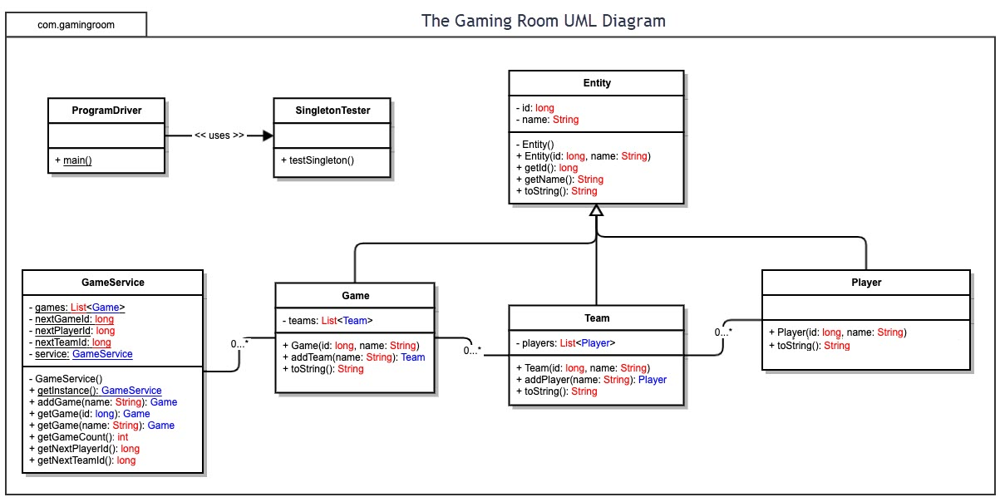

## Evaluation

Using your experience to evaluate the characteristics, advantages, and weaknesses of each operating platform (Linux, Mac, and Windows) as well as mobile devices, consider the requirements outlined below and articulate your findings for each. As you complete the table, keep in mind your client’s requirements and look at the situation holistically, as it all has to work together.

In each cell, remove the bracketed prompt and write your own paragraph response covering the indicated information.

| **Development Requirements** | **Mac** | **Linux** | **Windows** | **Mobile Devices** |
| --- | --- | --- | --- | --- |
| **Server Side** | Flexible terminal commands to configure the server, access, or make changes. | Same goes for mac plus more cost friendly | More software available compared to other OS. | It's better if the server is immobile and can be tracked at a single place. Specifications are better in other devices. |
| **Client Side** | Moderate expertise and time required. Cost similar to windows. What is required of the application development process to ensure the application is compatible with all web browser platforms and mobile devices? | Maximum expertise and time required. Minimum cost. What is required of the application development process to ensure the application is compatible with all web browser platforms and mobile devices? | Minimum expertise and time required. Cost similar to mac. What is required of the application development process to ensure the application is compatible with all web browser platforms and mobile devices? | Provides flexibility to clients or even developers to see updates at any place. Slightly more difficult to |
| **Development Tools** | When running on mac swift the more popular option. While mixing in nice tools like notepad++. Though Macs can run all languages. Languages consist of but not limited to HTML/CSS/JavaScri pt while supporting libraries to support the frontend and general purpose languages. These can be Java, Pyhton, PHP, and Ruby. | Linux can work with visual studio, eclipse, along with notepad++ for a nice and easy to use tool. Along with many more languages and tools. Languages consist of but not limited to HTML/CSS/JavaScr ipt while supporting libraries to support the frontend and general-purpose languages. These can be Java, Pyhton, PHP, and | Easier to use then linux but can run the same as it. So visual studio,eclipse to name a few of the many languages that can be used. And with multiple tools notepad++ is a simple to use tool. Languages consist of but not limited to HTML/CSS/JavaScr ipt while supporting libraries to support the frontend and general-purpose languages. These | You can create countless apps using android and swift. Both languages and software can be run on all three machines. Languages consist of but not limited to HTML/CSS/JavaScrip t while supporting libraries to support the frontend and general-purpose languages. These can be Java, Pyhton, PHP, and Ruby. |

## Recommendations

Analyze the characteristics of and techniques specific to various systems architectures and make a recommendation to The Gaming Room. Specifically, address the following:

1. **Operating Platform**: I would recommend The Gaming Room starts on windows devices as it has more software available along with minimum expertise and cost to get projects going. You also won’t run into a shortage of IDE’s to work with and free software to help with devploment.
2. **Operating Systems Architectures**: Windows provides services used by all windows-based applications that enable applications to show a Graphical User Interface (GUI), while accessing system resources and much more. These applications also refer to Graphics and Multimedia, messaging, and web services. These services can be used using a user account or a server specifically to get it runing
3. **Storage Management** Windows 10 comes with a nice feature called storage sense. This allows you to scrutinize and manage files on your hard drive, along with how much space it takes up. Other features include being able to choose save locations for apps making it easier to find. And just like other dives you can also use the cloud to save data on. The built-in storage system allows for easy file creation and placement for large projects, so they won’t get lost or carelessly deleted by mistake.
4. **Memory Management**: While creating this game you will need to create a database or library with lots of pictures. The memory allocation allows for easy storage of pictures outside of the default picture folder. This allows you to keep your whole project together in a more secure area on your computer.
5. **Distributed Systems and Networks**: Because each operating system being different I investigated ways to publish the game to run on all dives. I found Develop 4 which enables cross-platform game creation. It’s an IDE that can be run on any device. Once the game is created you can simply export the game file into web, iOS, Android, and many more options that will allow cross play. This will help with dependencies. To prevent other problems like outages or connectivity, the company will need to make sure their servers are strong enough to support large player volumes along with backup power for power outages and surges in online data.
6. **Security**: Windows comes with a built-in security protection software. Though to secure user data and information it would be recommended to use another source. Though if we are talking about what is on the machine windows comes pre equipped with protection. This system scan for malware (malicious software), viruses, and security threats. This all happens in real time, and because threats change the system updates automatically to keep the system and user data safe and out of the wrong handes